# CS 255 System Design Document

## UML Diagrams

### UML Use Case Diagram

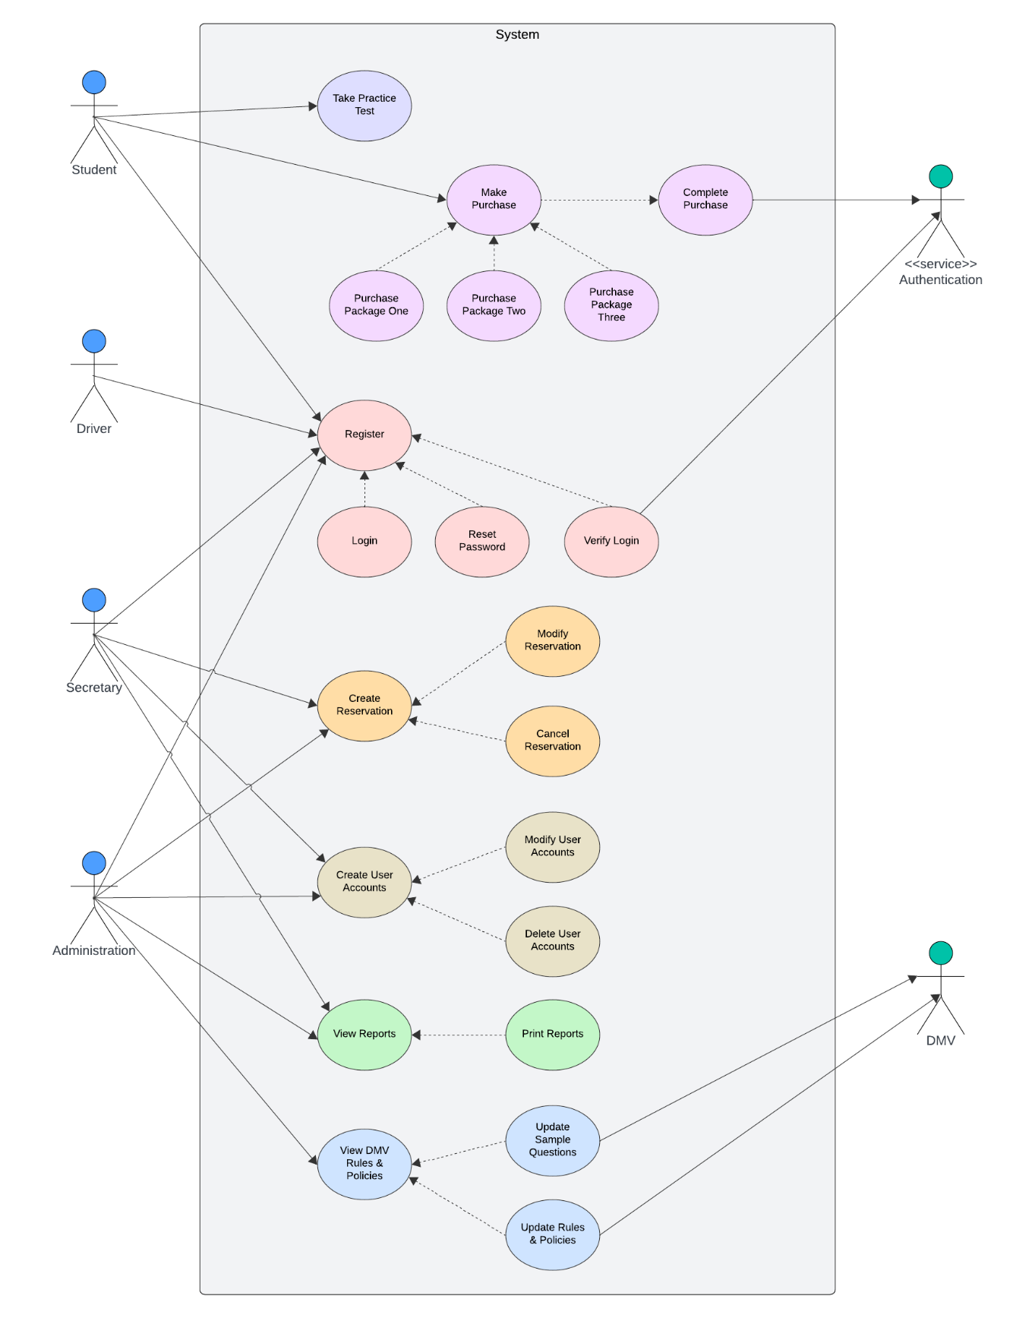

### UML Activity Diagrams

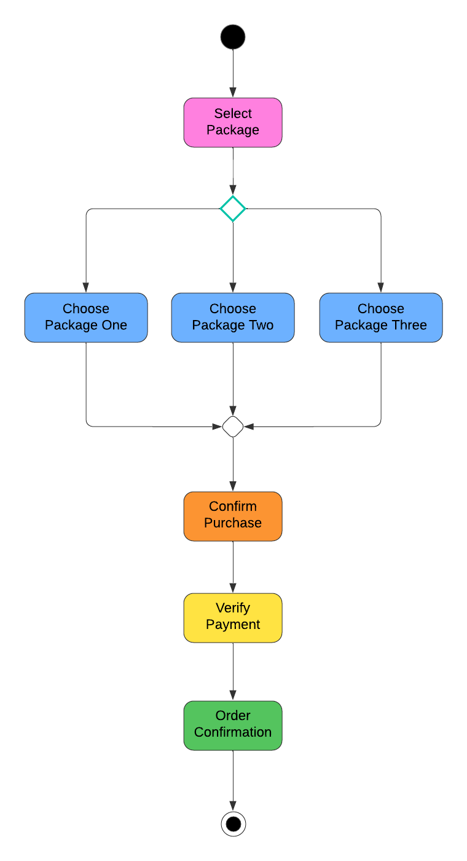

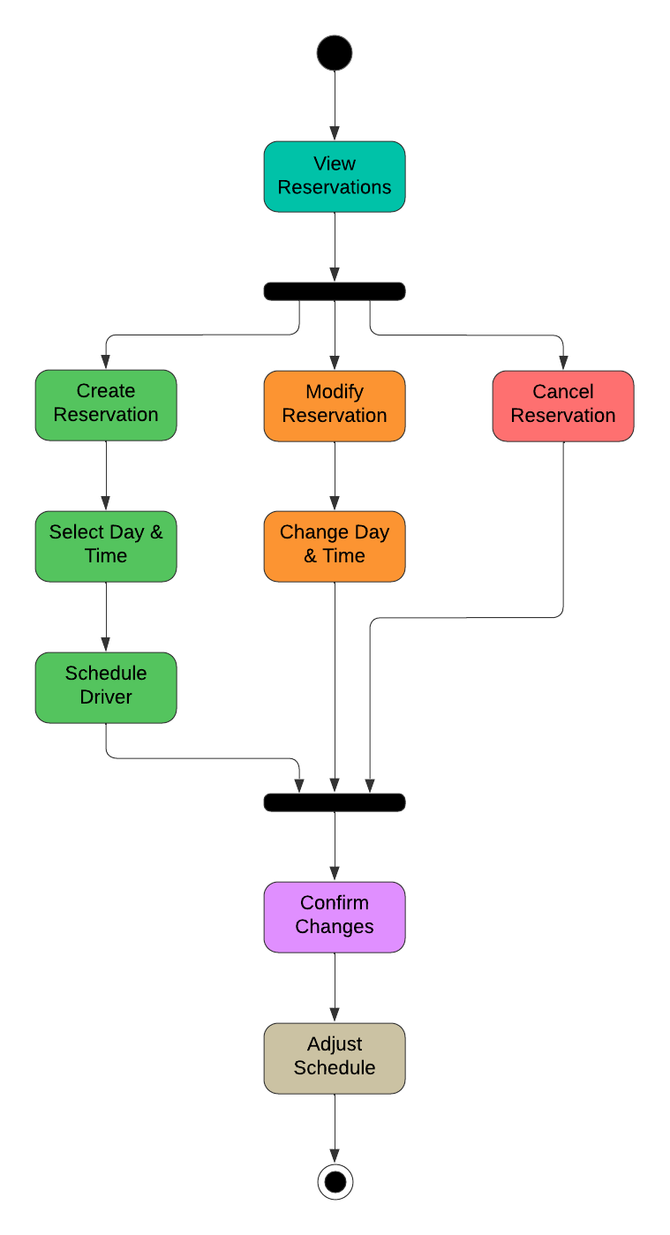

### UML Sequence Diagram

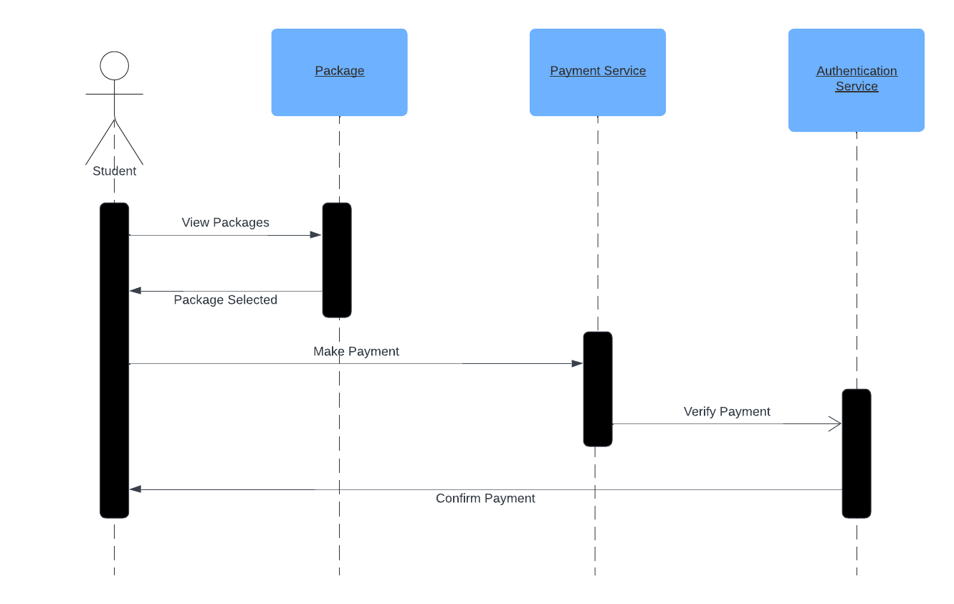

### UML Class Diagram

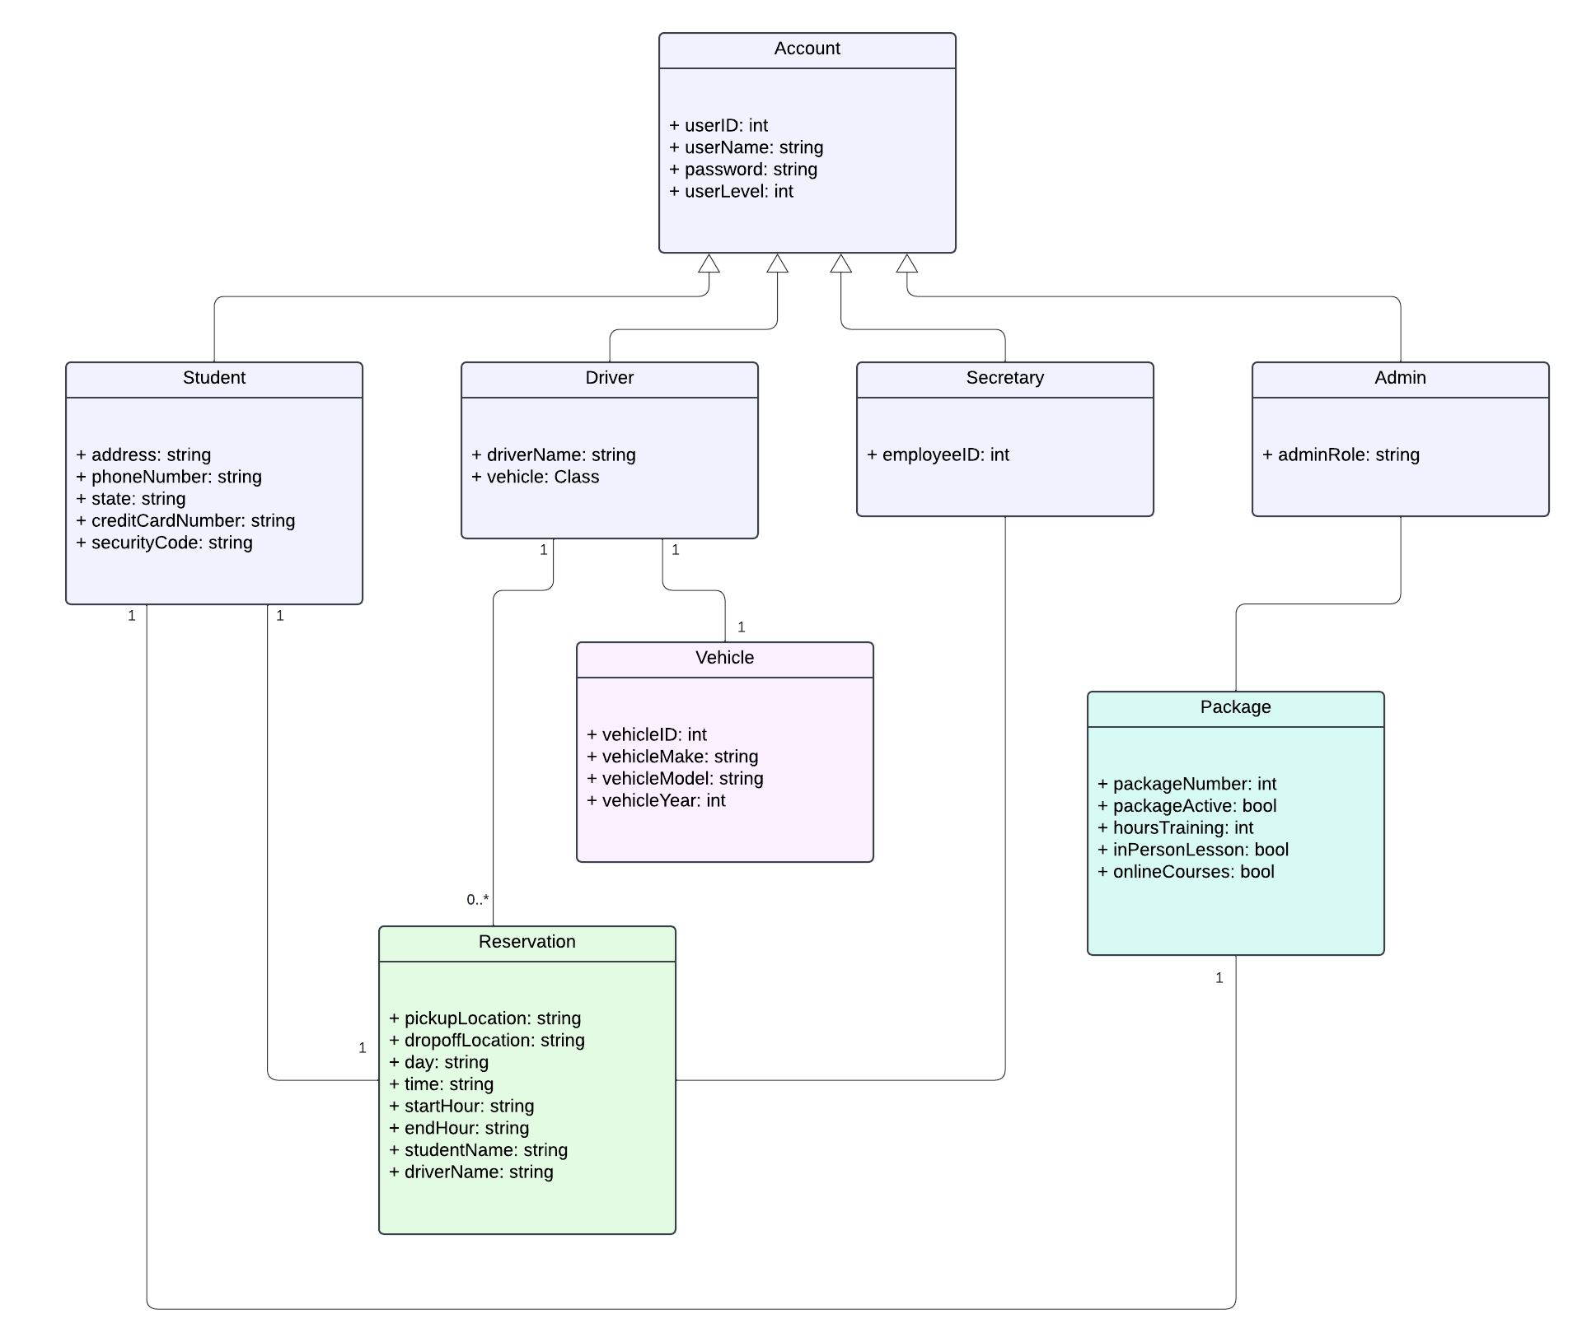

## Technical Requirements

* Hardware
  + Cloud-based server
* Software
  + Operating System capable of running web browser
  + Database for user and reservation information storage
  + Online testing platform
  + Payment processing service
* Tools
  + Security system for authentication and privacy
  + Communication/contact tools (messaging, email)
* Infrastructure
  + Internet connectivity
  + Automated backup